Hello everyone!!!
It’s spring time Jest już wiosenny czas. Dziś chciałam Was zaprosić na poznanie klasycznej książki o bardzo głodnej gąsienicy.
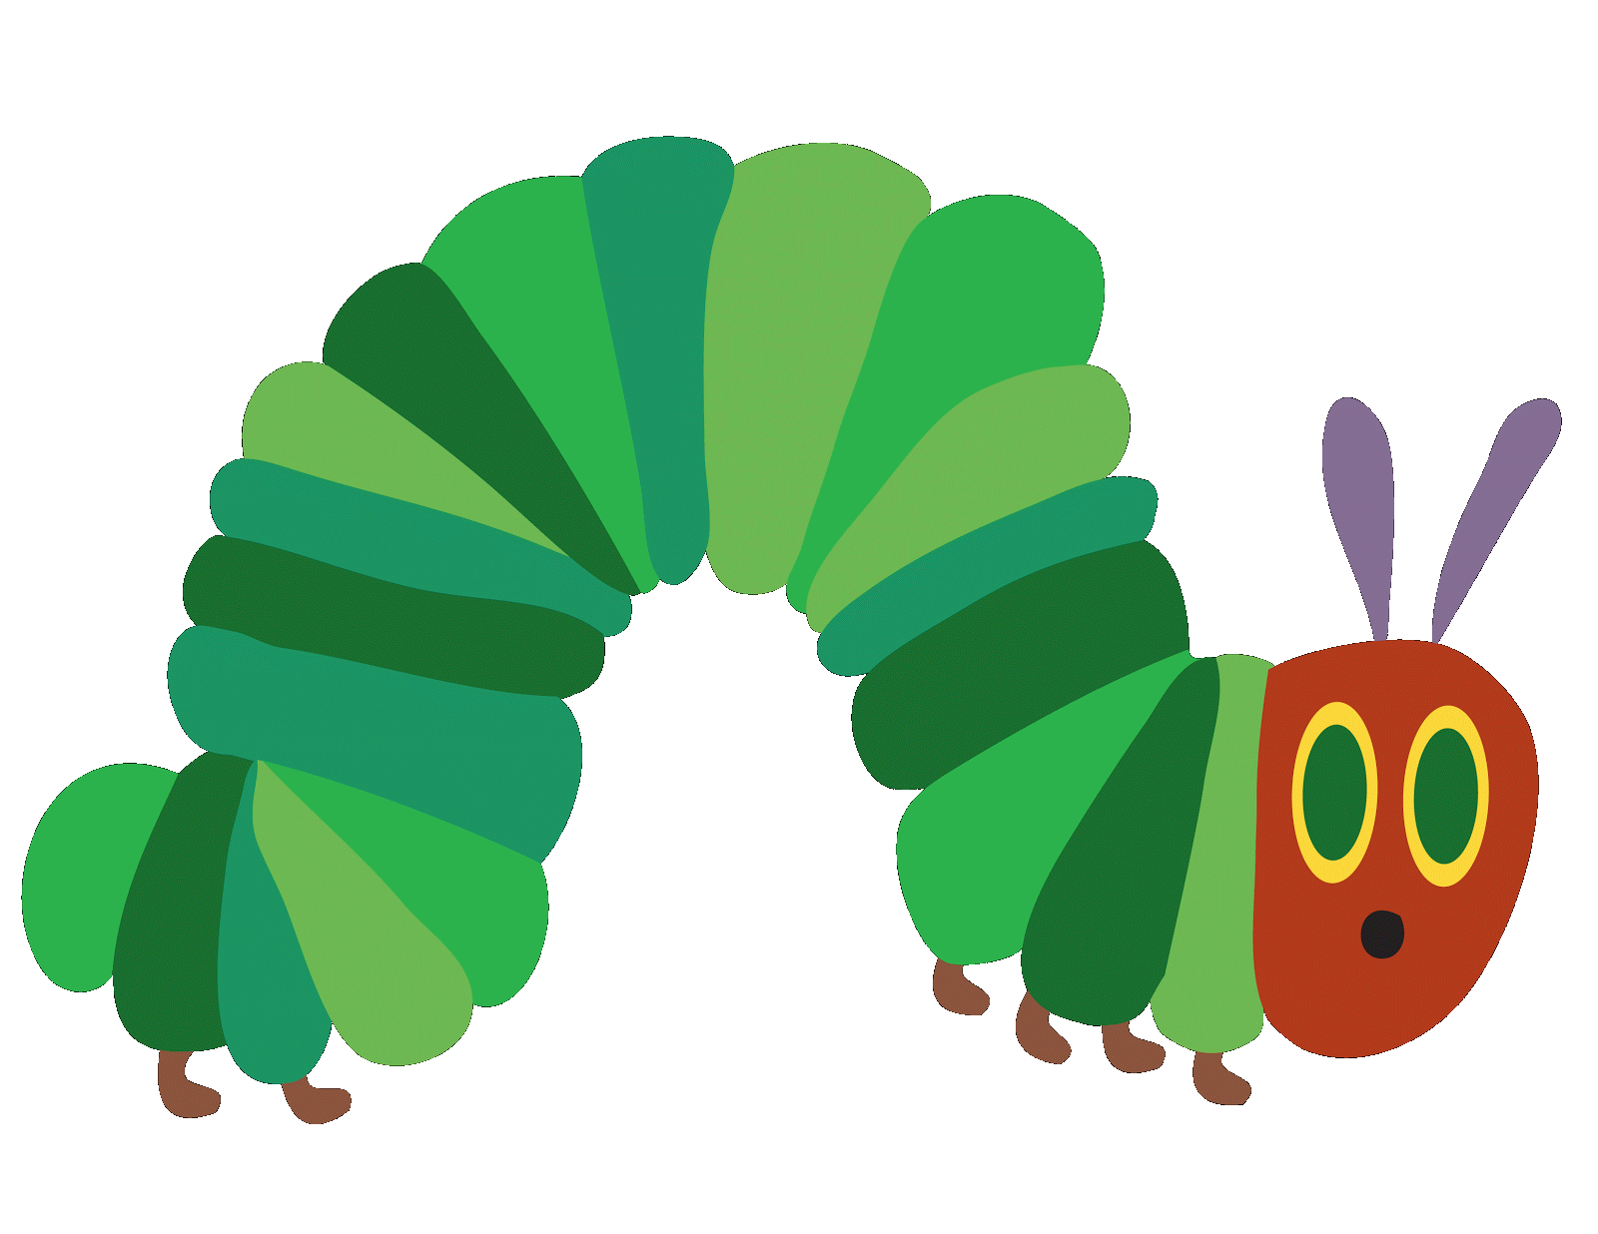 The very hungry catepillar by Eric Carle

https://www.youtube.com/watch?v=75NQK-Sm1YY&t=317s link do książki

Pictionary – czyli słownik obrazkowy

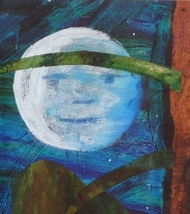 |  | 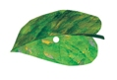 |  | 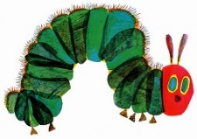
the moon | the sun | a leaf | an egg | a caterpillar
 | 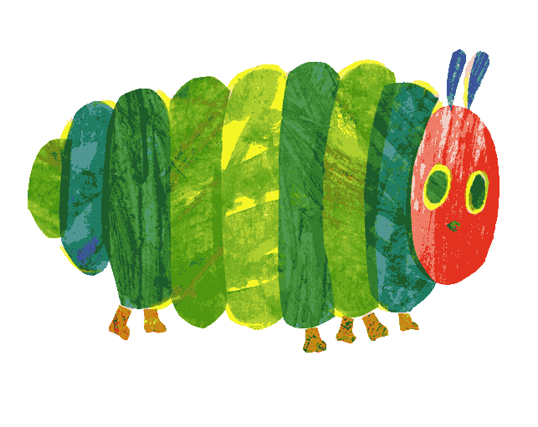 |  | 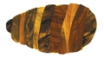
thin | fat | tiny | a cocoon | a butterfly
an apple | a pear | a plum | a strawberry | an orange
a piece of chocolate cake | an ice-cream cone | a pickle | a slice of Swiss cheese | a slice a salami
a lollipop | a piece of cherry pie | a sausage | a cupcake | a slice of watermelon

Activity 1

Read and colour – przeczytaj I pokoloruj

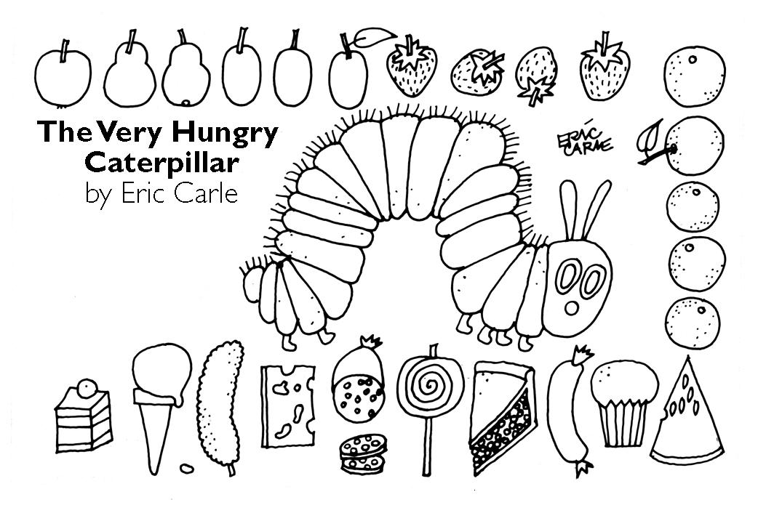
The apple is red.
The pears are green.
The plums are purple.
The strawberries are green and red.
The oranges are orange.
The water melon is green and red.
The cupcake is yellow and blue.
The sausage is red.
The cherry pie is brown and red.
The lollipop is blue and yellow.
The salami is pink and white.
The cheese is yellow.
The pickle is green.
The ice-cream is red and white.
The chocolate cake is brown.

Activity 2
The life cycle of a butterfly.

Put the pictures in the right order – ułóż w kolejności
 | 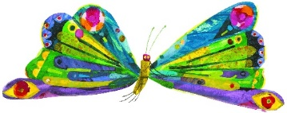 | Two weeks later the cocoon changes into a beautiful butterfly.
 |  | There is an egg on a leaf.
 |  | It grows fat.
 |  | The egg hatches into a tiny and very hungry caterpillar.
 |  | The caterpillar eats a lot.
 | 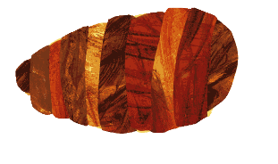 | It changes into a cocoon.

Activity 3
Make your own catepillar - Zrób swoją gąsienice!
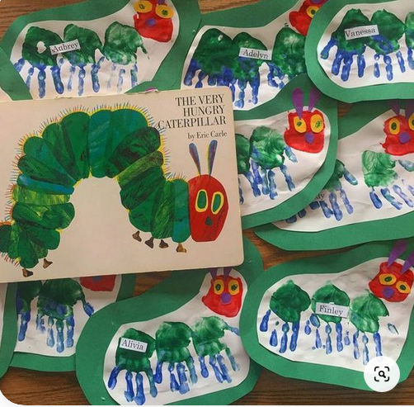
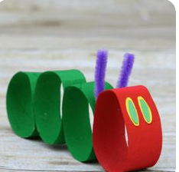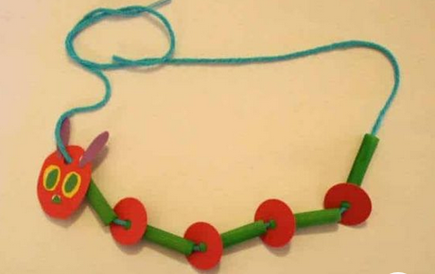
Źródło pinterst

Czekam na zdjęcia z Waszymi pomysłami !

